Woodstock High School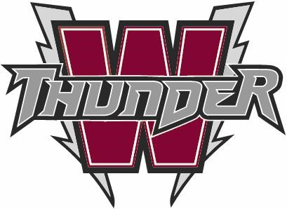
144 Connell Park Rd.
Woodstock, NB
E7M 1M4
Respect, Responsibility & Right Choices
Our School Mission: ACT Now for Preparing Your Future
PHONE: 325-4437
Principal: Bill Hogan, Vice Principals: Derrick O’Leary, Nicole Giberson

2020-2021 Course Selection for Students Entering Grade 10

Grade 9 Compulsory Program: Any subject not passed during 2019-2020 academic year must be repeated either in summer school (if available) or during the academic year 2020-2021.

Grade 10 Compulsory Program (all students) Any 2 of the following:

English (all year)
Plus
*Geomerty Measurement and Finance Music 10
French (Post Intensive Students) Visual Arts 10
FILA 10 (FI Students Only) Health and Physical Education (HPE) 10
Science
Social Studies
Personal Development and Career Planning

*Mathematics: Two separate courses make up the Grade 10 curriculum – Geometry, Measurement and Finance (GMF) 10 and Number, Relations and Functions (NRF) 10. GMF is required for graduation. NRF is now considered a credit course and is a prerequisite for Math Foundations 110, Physics 112, and Chemistry 112.

All Grade 10 students take one specialty course each semester. You need to provide us with your first and second choice for each semester. You cannot take the same specialty both semesters.

Elective Choices:
Music 10
The goals of this course are to offer students an opportunity to further develop technical and performance skills in voice, instrument (wind and percussion), keyboard and guitar. The students will also develop theory and aural skills, music literacy and discrimination skills. The course is fun and challenging for those who are interested in music.

Visual Arts 10
This is a course for students who have an interest in Art. The course designed to cover a variety of media, both 3-D and 2-D, as well as, art history and theory experienced through art projects. Students will have an opportunity to experience and explore each of the following types of media:
- Sculpture 3-D
- Drawing 2-D design
- Painting 2-D design

Health and Physical Education 10
This course is a prerequisite for Outdoor Pursuits 110, Wellness Through Physical Education 110 and Physical Education Leadership 120
Physical Education 10 is a class designed to introduce teenagers to lifetime fitness activities that will generate interest they will continue with after their high school years. Teachers will offer the students a variety of activities divided into units, with emphasis being placed on effort and interest rather than athletic ability. The course also has a Health Education component. Students will be evaluated on behavior, participation, attitude, preparedness and health theory. Depending on the semester that the course is taken, the activities may differ, but the main emphasis on all units will be on fitness. There is a final exam in the course.
- Activities that will be offered include:
  - Low Organized Games
  - Outdoor Activities (Golf, Cross-Country Skiing, Orienteering, Skating, etc.)
  - Badminton, Volleyball, Basketball, Soccer, Ultimate Frisbee, etc..
  - Fitness Themed Activities (Weight Training, Yoga, etc..)
  - Other Activities (Bowling, Curling, etc..)

Grade 10 Elective Courses

Grade 10 students will have the option of selecting two courses out of the following four. Please refer to the Course Selection Guide 2020-2021 that can be found on the WHS website for further descriptions of these courses.

Introduction to Applied Technology 110 – An introduction to trades classes.

Introduction to Family Dynamics 120 – Basic introduction of how families have changed and developed over the years.

Canadian Geography 120 – Studying Canadian landscapes such as mountain ranges, rivers, oceans and the dynamics they can create.

Numbers, Relations, and Functions 10 – This math course is a pre-requisite for students wanting to take Physics, Chemistry, or Foundations Math 110. You are required to pass this course before taking those high level science and math classes.

***Please consider your future plans when selecting your courses!

